CHAPTER 4

ANALYSIS AND DESIGN

Use Case Specification and UML Diagrams
Manage Title and Registration

4.1 Introduction
This document presents the detailed design of the second use case of the PSM Assessment System, namely Manage Title and Registration. The use case covers everything that happens between a student deciding to register and a project existing under an agreed title: the student files Lampiran A, the supervisor acknowledges it and chooses which of the proposed titles will be registered, and Lampiran B records the requirements before the supervisor signs it. It is specified in Table 4.2, then expressed as a sequence diagram in Figure 4.3 and an activity diagram in Figure 4.4.

4.2 Use Case Specification
Manage Title and Registration is the only route by which a title enters the system, and the only route by which a supervision pairing is created. It is one use case rather than two because the three documents are one chain: the agreement cannot be acknowledged without a title to agree to, and Lampiran B cannot be filed until the agreement is acknowledged. Table 4.2 summarises the use case.
Table 4.2: Use Case Specification for Manage Title and Registration
Use Case ID | UC-02
Use Case Name | Manage Title and Registration
Actor | Student (primary, for Lampiran A and Lampiran B), Supervisor (primary, for the acknowledgement and the signature), Coordinator and Admin (view and audit).
Description | The student registers for PSM 1 by filing Lampiran A, which records their particulars, up to three proposed titles and the supervisor they have approached. The supervisor acknowledges the agreement and, in doing so, chooses which of the three proposed titles the student will register. The acknowledgement is also the moment the supervision pairing is created. The student then files Lampiran B, which records the project type, the field of study and the software, hardware and technology the project requires, and the supervisor signs it. Signing opens the proposal milestone and the title proceeds to the panel.
Pre-condition | The student is signed in and an academic term is open for registration. The student holds no project and no agreement in flight for that term. The named supervisor exists, serves the student's programme and has capacity for the part.
Trigger | The student opens the registration form and submits Lampiran A.
Main Flow | 1. The student opens Lampiran A and selects the session from a list of terms.  2. The student enters their particulars and proposes up to three titles.  3. The student names a supervisor and submits the form.  4. The system confirms that a term is open for registration.  5. The system confirms that the student has no project and no open agreement.  6. The system validates each proposed title.  7. The system confirms that the supervisor serves the student's programme.  8. The system creates the agreement with the status pending supervisor.  9. The system notifies the supervisor that a Lampiran A awaits them.  10. The supervisor opens the agreement and chooses one of the proposed titles.  11. The system confirms the chosen title is one the student proposed.  12. The system creates the supervision assignment.  13. The system records the agreed title and marks the agreement approved.  14. The student fills Lampiran B and submits it.  15. The supervisor signs the form.  16. The system opens the proposal milestone.
Alternative Flow | A1. No term is open, a project already exists, or an agreement is already in flight: the system refuses the Lampiran A with 422 and names which of the three applies.  A2. A proposed title is unusable, being shorter than ten characters, fewer than three words, or a placeholder: the system refuses it and the student corrects it.  A3. The named supervisor does not serve the student's programme: the system refuses the submission. An unrecorded programme is allowed through, so that legacy staff rows are not locked out.  A4. The supervisor names a title the student did not propose: the system refuses it, because the acknowledgement is a choice between the candidates and a different title needs a new Lampiran A.  A5. The supervisor sends Lampiran B back instead of signing it: the form returns to the student as a draft with a reason, and the student re-files it.  A6. The student withdraws the filing before a project has been registered from it: the agreement is cancelled, the supervision is retired so the supervisor's capacity is released, and the pending form is cleared. Nothing is deleted.  A7. A project has already been registered from the agreement: withdrawal is refused, and unwinding it becomes a coordinator decision.
Post-condition | On success, the student holds an approved agreement naming one agreed title, a supervision pairing exists, and Lampiran B has been signed. The proposal milestone is open and the title goes to the panel at the title defence. The project's title is not fixed by this use case: it becomes the project's title only when a panel accepts it.

Three rules in Table 4.2 carry most of the weight. First, the agreed title is chosen and not typed (A4): Part C of Lampiran A offers the three candidates as a list, so the title the supervisor agrees to and the title the panel is later asked to consider are always the same string. Second, acknowledgement is where the pairing is created, not a second approval step, which is why the supervisor judges the supervision while the panel judges the title. Third, withdrawal is a student's act and never a deletion (A6, A7): the agreement keeps its timestamps and its proposed titles, because the faculty's file has to show what was submitted and when.
The programme check in A3 deliberately fails open. A staff row with no recorded programme permits the pairing, so legacy records are not locked out; the consequence is that a staff row with no programme enforces nothing, which is why every programme is seeded with four staff.

4.3 Sequence Diagram
The sequence diagram in Figure 4.3 shows the whole chain across six lifelines: the student or supervisor, the registration interface, the registration controller, the registration service, the agreement and supervision data, and the Lampiran B and milestone data. It is divided into four sections because four things happen in sequence and each has its own rules.
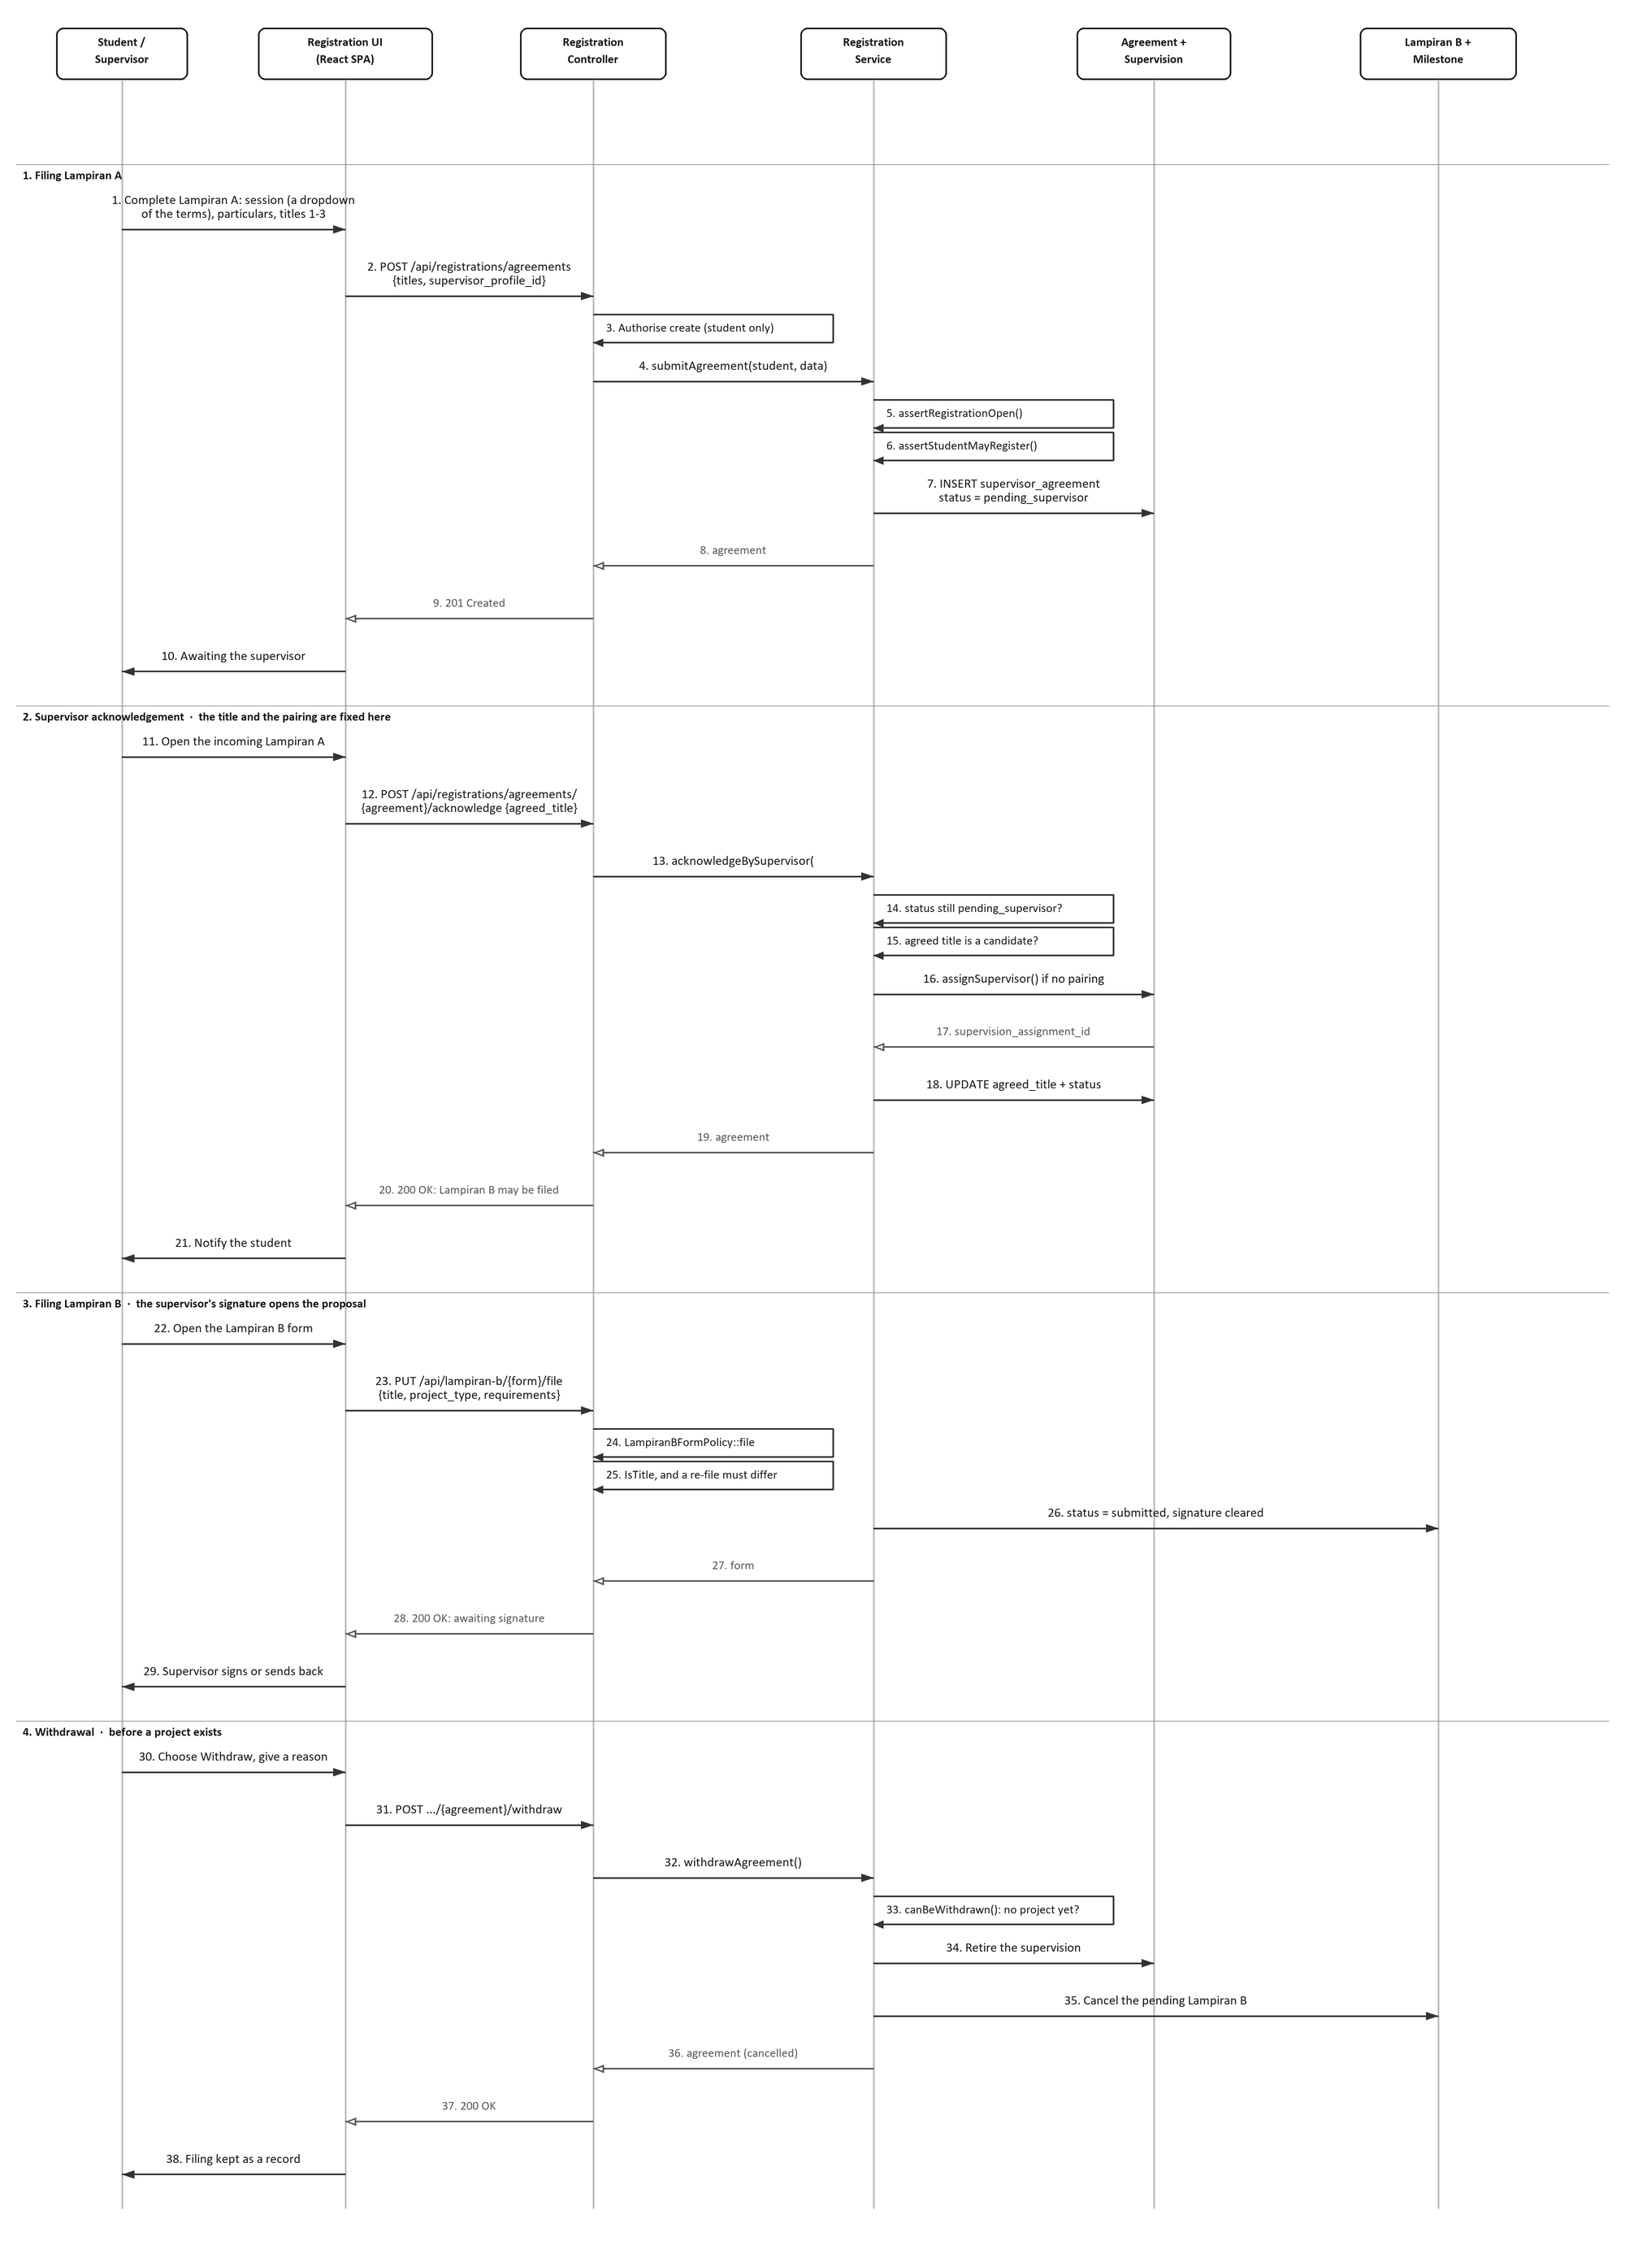
Figure 4.3: Sequence Diagram for Manage Title and Registration
The first section is the filing. Messages 4 to 7 show the two guards that run before any record is written, and only then does message 7 insert the agreement. The second section is the acknowledgement, and it is the busiest part of the diagram: message 14 confirms the agreement is still waiting, message 15 confirms the chosen title is one of the candidates, message 16 creates the supervision assignment, and message 18 writes both the agreed title and the approved status in one update.
The third section files Lampiran B. Message 24 applies the policy, which needs the form to belong to the caller and to be a draft; message 25 applies the title rule. Message 26 is worth noting: submitting Lampiran B clears any previous supervisor signature, because a signature on one title does not cover another. The fourth section is withdrawal, and message 33 is the guard that makes it narrow: the filing can only be taken back while no project has been registered from it.

4.4 Activity Diagram
The activity diagram in Figure 4.4 shows the same use case as a workflow. The filing route runs down the centre through four decisions, each of which corresponds to an alternative flow in Table 4.2, and the withdrawal route branches to the left from the point where a Lampiran B is filed but no project exists. Both converge on one end node.
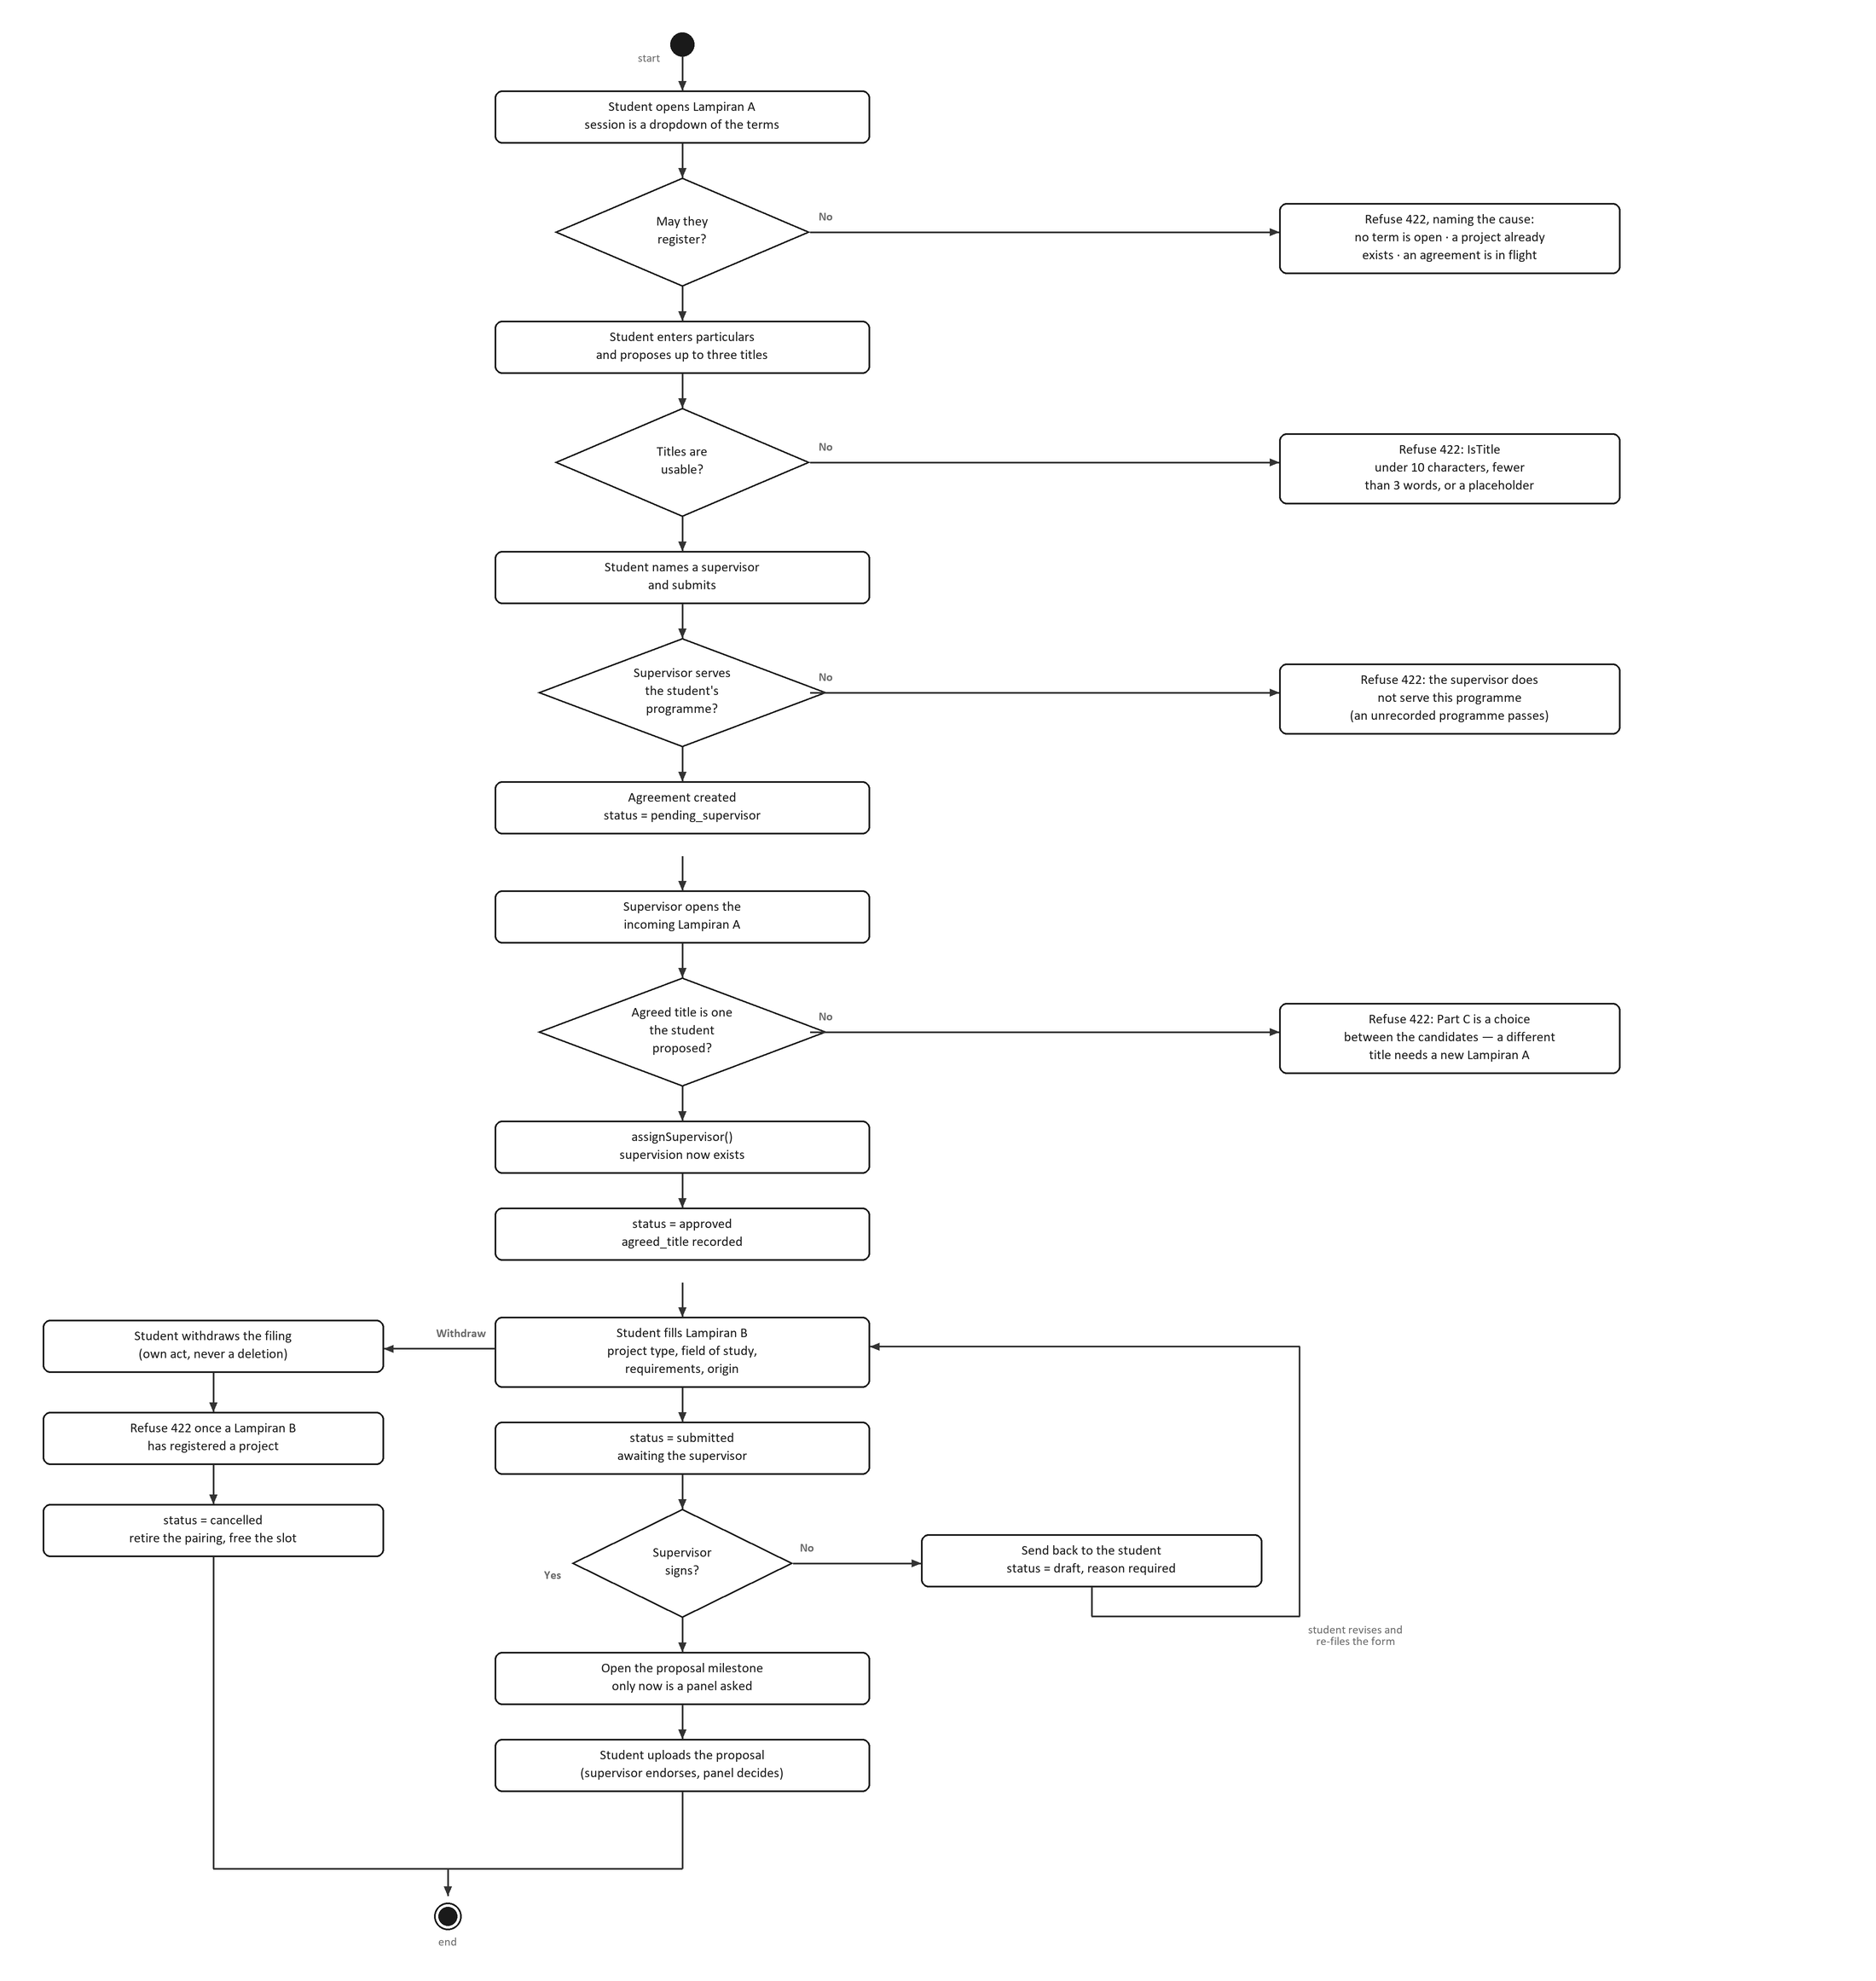
Figure 4.4: Activity Diagram for Manage Title and Registration
Each decision in the centre is a refusal that names its own cause rather than returning a generic error: whether the student may register at all, whether the proposed titles are usable, whether the supervisor serves the student's programme, and whether the supervisor's chosen title is one the student proposed. The withdrawal branch keeps its own guard, refusing once a Lampiran B has registered a project, and its success path cancels the agreement and retires the pairing so the supervisor's capacity comes back.
The final decision is the supervisor's signature. The Yes path is the only path on which the proposal milestone opens, which is the point of the whole use case: no title reaches a panel until a supervisor has agreed to supervise it.

4.5 Chapter Summary
This document has specified the Manage Title and Registration use case and presented its sequence diagram and activity diagram. The specification defines two primary actors, a sixteen step main flow and seven alternative flows. The sequence diagram shows the four stages of the chain as message exchanges across six objects, and the activity diagram shows the filing route with its four guards beside a withdrawal route that is deliberately narrow.

